Let’s get ready to Rumblee.

Chrome Extension Software Requirements (Rocket Planner)

# Goals

1. Create the best and easiest user experience for the user to plan their day
2. Add the ability for the user to see the progress of their tasks for the day
3. Have the user focus on a plan of action vs. tasks for the day

# User Stories

As a <User>, I want <Goal> so that <some reason>

1. As a user, I want to see a list of all my plan of action items so that I can view the plan of action for the day
2. As a user, I want to add an action item so that I can continue adding to my plan of action for the day
3. As a user, I want to delete an action item so that I can remove any unnecessary m item
4. As a user, I want to be able to mark may items completed so that I can view action items that are completed
5. As a user , I want to see percentage progress so that I can see my daily progress for the day
6. As a user, I want to quickly add frequently done action items so that I can save time
7. As a user, I want to make a website a task so that I can come back later read that website
8. As a user, I want to be greeted so that I can have a welcoming user experience as I open up the app
9. As a user, I want to edit my name in the greeting so that I can be greeted with the correct name.

# Flow Diagram(Swimlane)

Shows who does what in the process (Example)

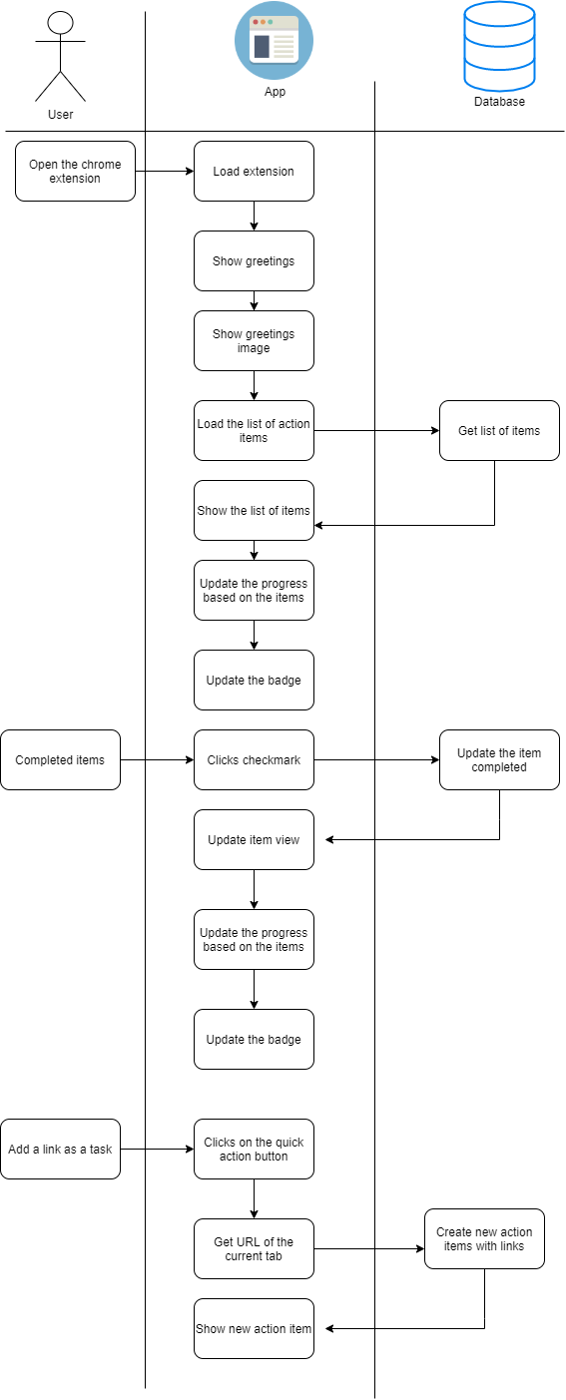

# Business Requirements

1. Allow a user to see action items for the day
2. Allow a user to add new action items for the day
3. Allow a user to bookmark any site as a task
4. Allow a user to delete an action item
5. Allow a user to mark an action item completed
6. Show percentage progress of items for the day
7. Do not show completed items from the previous day
8. Greet the user with the words
9. Good morning, good afternoon, good evening, good night.
10. Display an image representing the time of the day
11. Morning, afternoon, evening, night.
12. Show the users name in the greeting as the following
13. Good morning Benjamin.
14. Allow a user to be able to easily edit their name
15. Give a user 3 quick action items to use:
16. Gym
17. Link site for later
18. Mediate
19. Provide a nice user experience through clean animations on action items.
20. Remove the need for any login

https://www.figma.com/file/I513Dyrxvhcfqw4lbE3OOd/Rocket-Planner-Official?node-id=0%3A1

Technical Requirements

* Use Chrome Storage as a database to save data
  + <https://developers.chrome.com/extensions/storage>